Week4 Module4 Assignment1
1. Connect to PostgreSQL
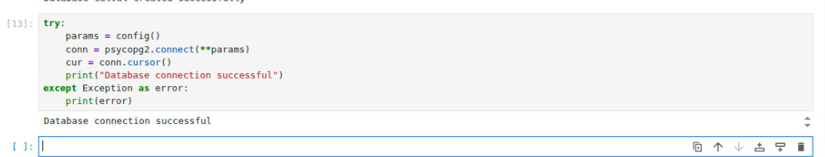
2. Create Nutrient Description Table
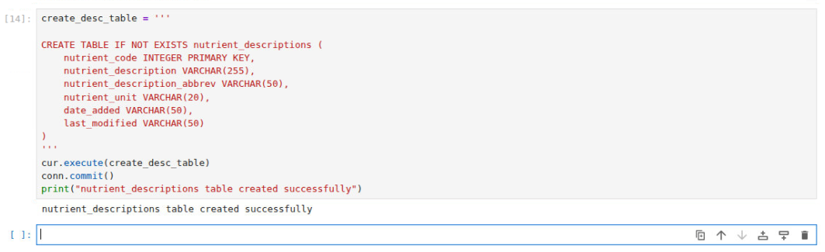
3. Create Nutrient Values Table
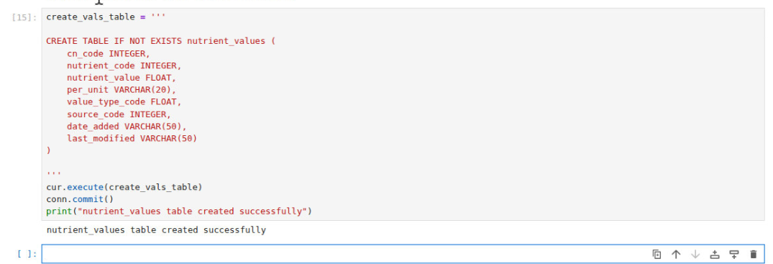
4. Load CSV Files
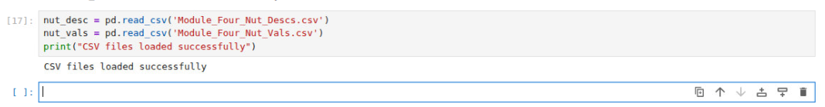
5. Display Nutrient Description CSV
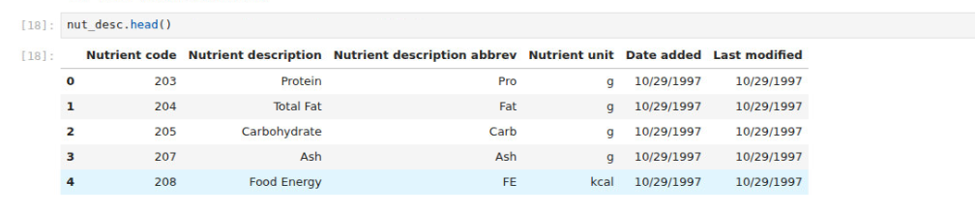
6. Display Nutrient Values CSV
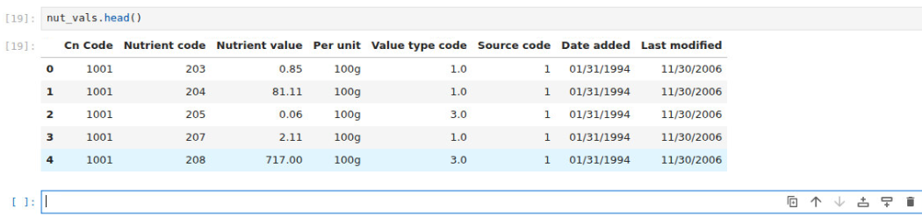
7. Create new record function
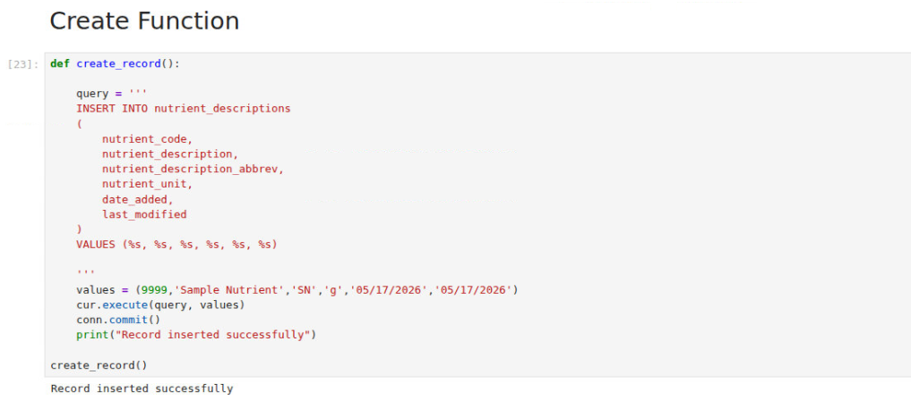
7. Read a Record
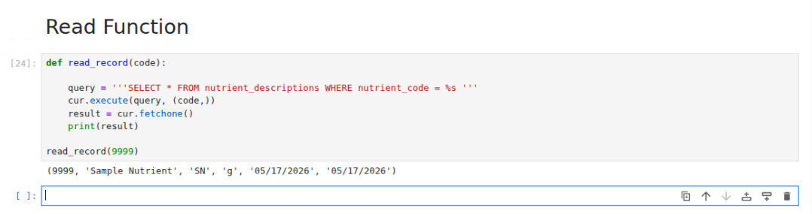
8. Update a Record
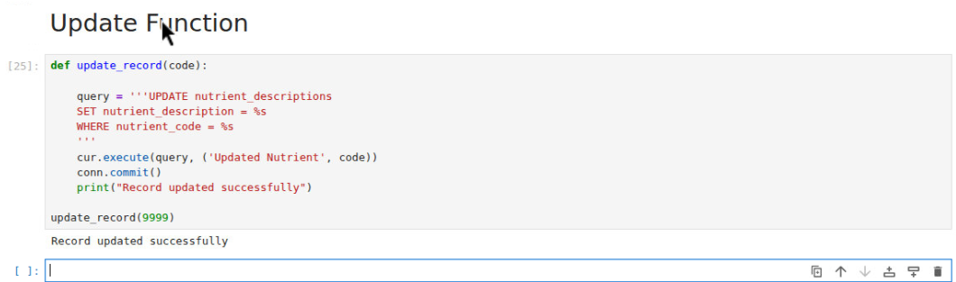
9. Delete Function
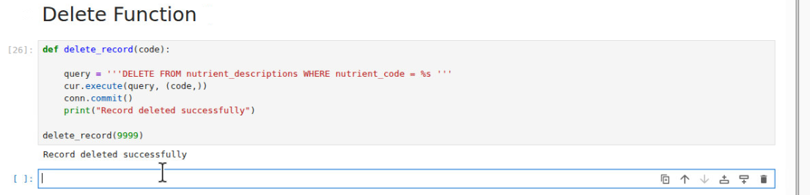
10. Insert CSV Data Into Table nutrient_descriptions table
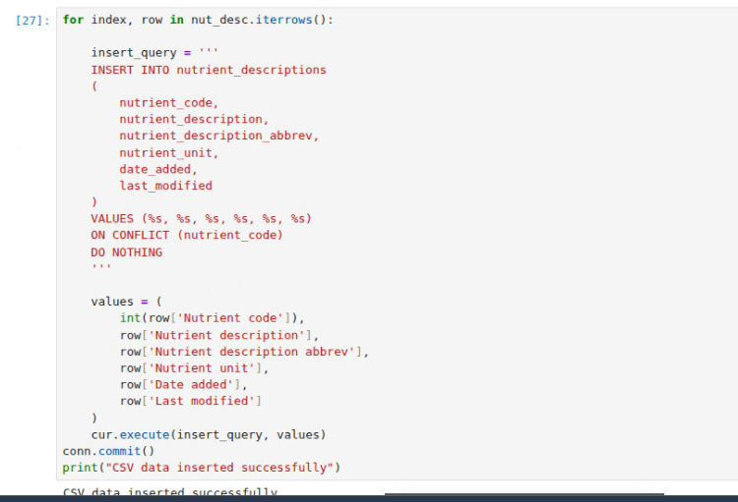
11. Verify CSV Data
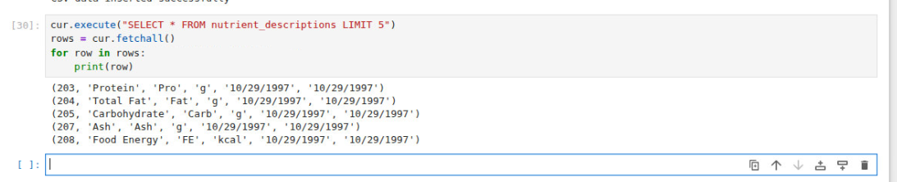
12. ETL Explanation
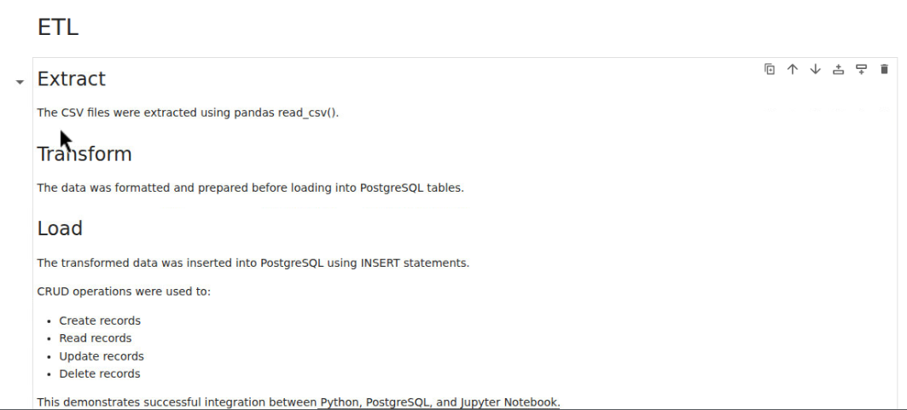
13. Close Connection
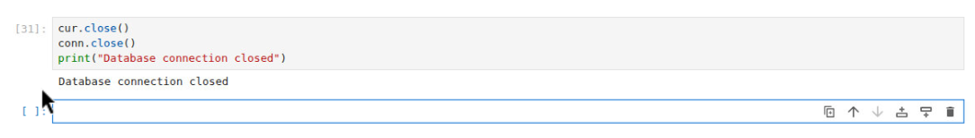
Github Screenshot

